Herbert R. Hartel, Jr.
196-41 69th Avenue
2nd floor
Fresh Meadows, NY 11365

DOVE, ARTHUR Word Count: 533

Arthur Dove (1880-1946) was a pioneer of abstraction and probably the first American to create purely non-representational paintings. His interest in natural forces, processes and forms inspired most of his work. His use of nature epitomises a broad trend in early American modernist painting that includes many artists in the Alfred Stieglitz circle. Dove came from the Finger Lakes region of New York. He studied at Hobart College and Cornell University, and graduated from the latter in 1903. He was always deeply fascinated by nature and analysed it carefully. After college, Dove earned a living by producing commercial illustrations and operating farms in Connecticut. He traveled after college and studied European modernism, as Still Life with Lobster (1908) demonstrates. Dove’s breakthrough to abstraction occurred around 1910 and continued for about four years in numerous small works done with charcoal and pastel on paper. Dove’s early works became notorious when many of them were exhibited in 1912 at Alfred Stieglitz’s gallery 291 and the Thurber Gallery in Chicago. Their notoriety later earned some of them the provocative title of the ‘Ten Commandments.’

Dove’s early abstractions are muted or monochromic in colour. These works include Abstractions No. 1 to No. 6, Nature Symbolized No. 1 to No. 3, Plant Forms and Movement No. 1. Although a few feature architectural and landscape imagery, most are based on plants, flowers, leaves, trees, wind, rain and other natural forms and processes and are highly abstracted. In the early-1920s, Dove resumed painting after several years during which financial and family obligations kept him from art. At this time he began working on a larger scale using oils, sometimes mixed with wax emulsions, and worked on various surfaces, including canvas, sheet metal, and tin. These unusual mixtures and surfaces allowed intriguing textural effects for visualizing natural forms and phenomena. By now his interests expanded to include birds, moving water, clouds, the moon, the sun, stars, and synaesthetic experiences of colour, light, and sounds. He developed various pictorial devices to suggest growth, movement and energy, such as using rhythmic force lines surrounding forms similar to those used by the Futurists. Among his best works from the early-1920s until his death are Fog Horns (1929), Green and Purple–Seagull Motif (1929), A Field of Grain as Seen from a Train (1931), Rain or Snow (1944) and That Red One (1944). Dove actively painted until he died in 1946. He was romantically involved with the artist Helen Torr from 1920 until his death, and they were married in 1932. Financial success eluded him during his lifetime although he was strongly supported and promoted by Alfred Stieglitz.

References and Further Reading
Balken, D. B et al. (1997) Arthur Dove: A Retrospective. Boston: M.I.T. Press.
Cohn, S. (1989) Arthur Dove: Nature as Symbol. Ann Arbor, MI: UMI Research Press.
Hartel, Jr., H. R. (2012) “Reconsidering Nature as Inspiration and Meaning in the Early Abstract Paintings of Arthur Dove.” New York History, 92.1-2, Winter / Spring, 65-77.
-----. (2011) “What is the Subject of Arthur Dove’s Abstraction No. 2, 1910-1911?” Source: Notes in the History of Art 31.1, Fall, 37-42.
Haskell, B. (1974) Arthur Dove. Boston: New York Graphic Society.
Kirschner, M. (1998) Arthur Dove: Watercolors and Pastels. New York: George Braziller.

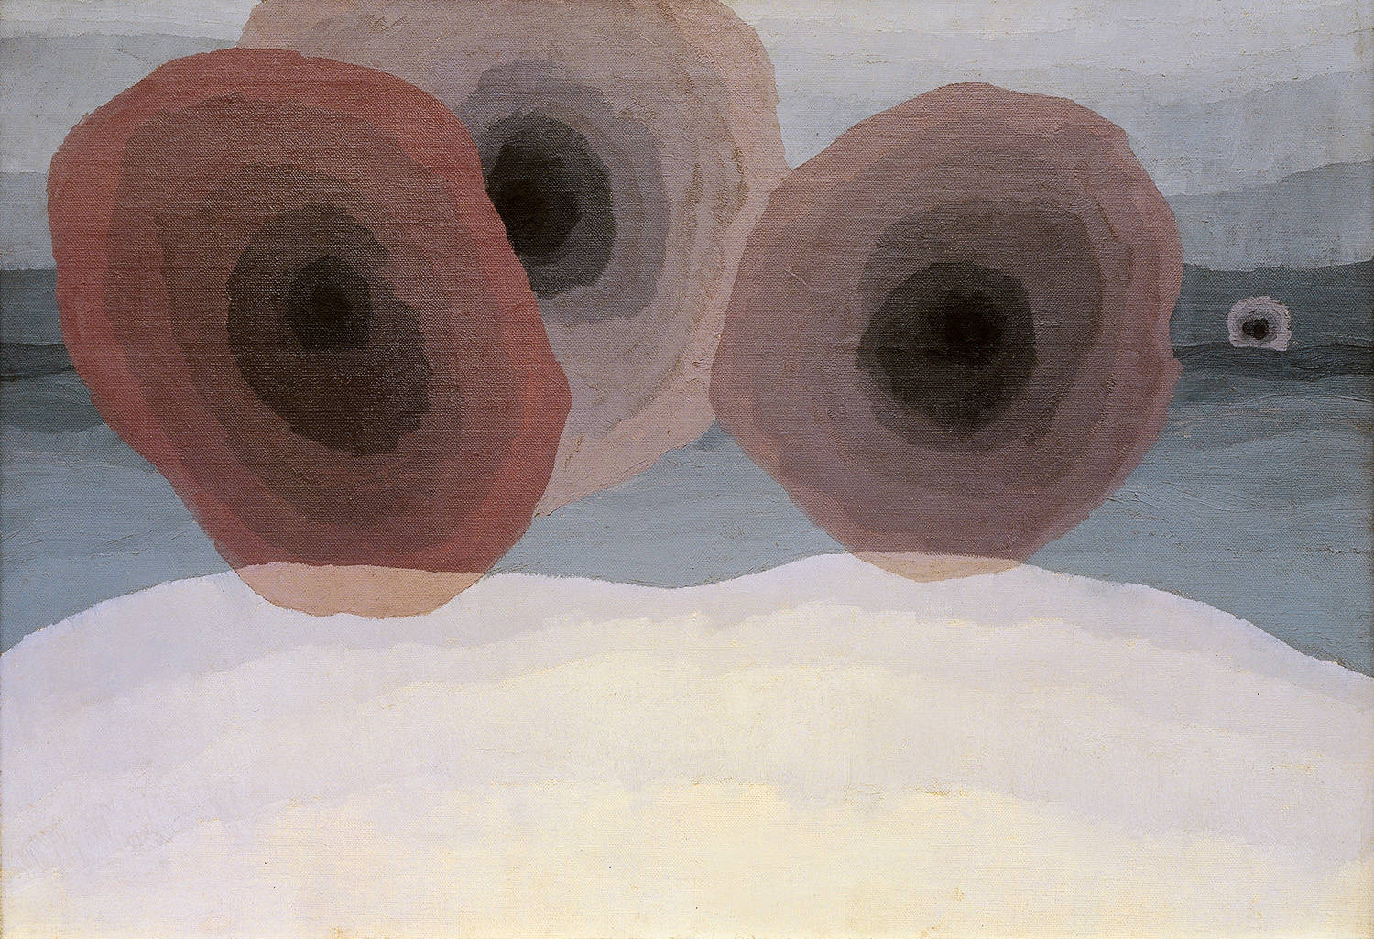

Arthur Dove (American, 1880-1946). Fog Horns, 1929. Oil on canvas. 21 1/2 x 28 1/2 in. (54.6 x 72.4 cm). Colorado Springs Fine Arts Center.
http://www.csfineartscenter.org/information.asp

